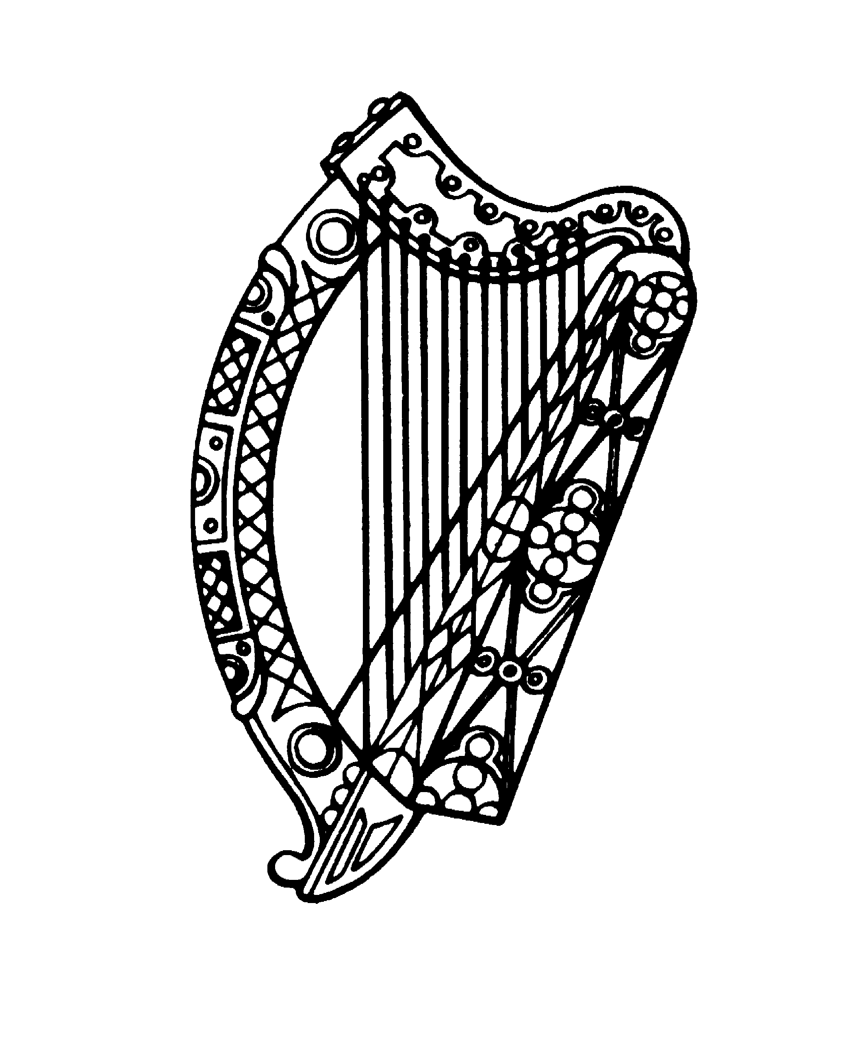

The Hon. Mr. Justice Frank Clarke
Chief Justice of Ireland
______________________________________________

Address at Fordham University School of Law
Thursday 13th September 2018

“Ireland as a Common Law Port after Brexit”

It is indeed a pleasure and an honour to speak to such a distinguished audience on a topic which, in my view, is of singular importance to Ireland, to the European Union, to the United Kingdom and, indeed, to countries such as the United States which have close relations with all of us. The problems which will arise from Brexit span so many areas. In particular the consequences for Ireland of the possible re-emergence of a hard border between North and South is potentially a critical issue. Like any other citizen of Ireland and of the EU I have opinions on many of these matters. However, the aspect of Brexit on which I feel both qualified and entitled to speak with some authority is that concerning its impact both on the European legal order and on legal issues involving other friendly countries, again in particular the United States, which have regular dealings with Europe.

As it happens I qualified at the Bar of Ireland in the same year that both Ireland and the United Kingdom joined the then European Economic Community. At that time European law was, perhaps, remote to most practitioners save for a small number of specialists. However, over the 4½ decades which have passed since that time, the reach of European law into the legal systems of the member states has grown to a very significant extent such that many areas affecting the ordinary practice of lawyers, regulators, public officials and the courts are now either almost fully, or at least to a material and significant extent, governed or influenced by EU law. It is, I think, fair to say that in many areas EU law has become entwined with the national legal order of member states and it is that very fact which makes the disentanglement required by Brexit all the more problematic.

In this address I hope to explore both the challenges and opportunities which those problems bring. The challenges stem from the fact that Ireland will almost certainly have to play a leading role, post Brexit, as the main common law jurisdiction remaining within the European Union. On the other hand, that very fact provides opportunities for the Irish legal system, including its courts and arbitral tribunals, to act in a significantly expanded way as a location for dispute resolution in international litigation, including insolvency, where both the common law and recognition throughout the European Union are of importance.

There must, of course, remain some possibility that Brexit will not happen. The growth of the “Peoples’ Vote” movement in the UK, which seeks a second vote on the Brexit question when the final terms on which the UK will ultimately be expected to leave the EU are clear, is a case in point. I would leave it to others, not least Consul General Madden, to answer any questions which you might have on the likelihood of Brexit not taking place. However, realistically, it must be the case that by far the most likely outcome is that the UK will leave the European Union on some basis. What that basis will be is particularly unclear not least in relation to the sort of questions which I hope to address. Thus, one of the difficulties which we are all facing is the extraordinary level of uncertainty about what the legal order in Europe will be in the future.

To avoid over-complicating this address by matters of legal detail I have prepared, in conjunction with my judicial assistant, Luke McCann, a paper which addresses in more detail some of the key legal issues and cites some of the relevant materials. As that paper points out, March next year (which is, after all, only six months away now) is the date on which the notice given by the United Kingdom, in accordance with Article 50 of the Treaty on European Union, indicating its desire to withdraw from the Union, will expire. That period can only be extended by the unanimous agreement of the United Kingdom and each of the other member states of the EU. Furthermore, Article 50 contemplates the possibility of a withdrawal agreement setting out the terms on which the United Kingdom is to leave the European Union but makes clear that, in the absence of such an agreement, the United Kingdom will, on the expiry of the notice period, simply become a third party country so far as the EU is concerned with no special or particular relationship. Whether a withdrawal agreement can successfully be negotiated is a matter which is still very much up in the air and, in a much used phrase in Europe at the moment, the clock is ticking not least because any such agreement requires to be ratified by each member state in accordance with its own national procedures prior to the withdrawal date.

Assuming that both sides can come to a withdrawal agreement in time, the current negotiating draft suggests that there may be a transitional period where things will remain more or less the same until, perhaps, the 31st December 2020, during which time a further agreement setting out the future relationship of the UK with the EU might be negotiated. There are, thus, two critical points in time. The first is the expiry of the Article 50 notice in March of next year which might lead to a fairly chaotic departure of the UK from the EU in the absence of a withdrawal agreement. The second, in the event that there is a withdrawal agreement, will likely arise on 31st December 2020 when the future relations between the EU and the UK will be the subject of further arrangements as yet unnegotiated or, in the absence of agreement, will revert to what might be described as third party nation status.

I would particularly emphasise that both of these dates, March 2019 and December 2020, are in the fairly near future. Contracts and arrangements entered into today are likely to come to be considered by courts, regulators or others exercising legal power over the next number of years and today’s arrangements may well fall to be resolved by the legal order which will be in place either after March of next year or from January 2021. The uncertainty which pervades the type of legal order which will then prevail has a very real potential, therefore, to affect the outcome of arrangements entered into today. The uncertainty to which that gives rise and the challenges and opportunities which follow are the particular focus of the issues which I want to address here today.

I might turn first to the challenges. As many of you will know Ireland is essentially a common law country with a legal system which would be broadly familiar to any American lawyer. In the current European Union there are only four jurisdictions which are either substantially or at least partially in the common law fold. The UK is, of course, by far the largest. Ireland, although a lot smaller than the UK, is in second place with a population approaching 5 million. The private law of Cyprus is largely derived from common law although much has now been codified in statute. However, its public law derives from the civil law continental tradition. It can fairly be described as having a mixed system. Also if Ireland is a lot smaller than the UK, then Cyprus is a lot smaller again with a population of just over 1 million. Considerable work has been done in recent times to enhance judicial co-operation between Cyprus and Ireland and it is likely that that situation will very much continue post Brexit. Indeed in that context I will later this month have the honour, at the invitation of the President of the Supreme Court of Cyprus, Justice Myron Nicolatos, to address the Senior Judiciary of Cyprus on matters of mutual interest.

Finally, there is Malta. Malta also has what has been described as a mixed legal system having originally been part of the civil law tradition but having, during a period of British rule, also adopted many common law practices. Malta is smaller again than Cyprus with a population of under 500,000.

From that brief analysis it will be seen that, post Brexit, Ireland will be by far the largest common law country in the EU and will, in substance, be the only country whose legal system could reasonably be described as being fully in the common law tradition with both Cyprus and Malta having, to a greater or lesser extent, a mixed system.

The challenges which this will bring are, in my view, substantial. European Union legislation must pass both the Council of Ministers, on which each member state is represented, and the European Parliament. Even today both of those bodies have a significant majority from the civil law tradition. It is undoubtedly the case that the crafting of European legislation which can fit, without unintended consequences, into the legal order of member states with differing legal traditions has always been a challenge. Indeed, in that context, it is worth recording that those of us in the common law world tend sometimes to view the civil law jurisdictions as being all the same. In truth, however, there are also different strands within the civil law tradition which make for even greater difficulty in avoiding unintended consequences from the introduction of harmonised laws.

That being said I have not noticed any unwillingness on the part of those from other legal traditions to seek to accommodate the need to tweak proposed measures so as to make them more easily transposed into the national law of countries from the common law tradition. But in order for that to happen there has to be an effective common law voice at the table which points out the potential difficulties and negotiates appropriate solutions. I think it is fair to say that, in the past, the smaller EU common law countries have placed significant reliance on the UK both to do the research necessary to identify potential problems for the transposition of proposed EU legislative measures into a common law jurisdiction and also to make the case to the European institutions for solutions. Unless a particular Irish, Cypriot or Maltese angle was identified then the smaller countries could largely rely on the UK to fight the common law corner. But that will be no longer the case post Brexit. We will have to fight our own corner and it is fair to say that, as both by far the largest and the only fully remaining common law jurisdiction post Brexit, Ireland will have to play a leading role in that regard. But playing that leading role will bring its own challenges for a relatively small country.

I might just give some brief examples from my own experience in being involved, both as a Judge of the Supreme Court and laterally as Chief Justice, in the variety of European Courts bodies with which we are associated.

Ireland, like the United States, has a single Supreme Court for all types of litigation. However, many European countries operate on a different basis. For example, many jurisdictions have a separate constitutional court or tribunal charged with dealing with constitutional issues. In addition a majority of EU member States have a separate strand of courts or decision making bodies to deal with public or administrative law as opposed to private law litigation whether civil or criminal. There are, therefore, three separate European Court organisations representative of the highest level courts in respectively constitutional, public or administrative and private law. As a court which carries out all three roles in Ireland, our Supreme Court is a member of each of those bodies which places a particular burden in ensuring that we are effectively represented.

However, I have increasingly found that those bodies are more than willing and indeed anxious to ensure that there is a common law voice on their committees and working groups so that each tradition within the European Union has its voice fully heard. In the past the UK has played a significant role in that regard but increasingly Ireland is being asked to nominate senior judges to these many bodies.

In common with most Supreme Courts in the common law world, Ireland has a court with relatively small numbers. It may surprise many of you to know that Supreme Courts in the civil law tradition frequently have judicial numbers closer to 100 than 10 sitting in many divisions or panels. The burden of ensuring that we play the role which is increasingly being thrust upon us to represent the common law voice on these many bodies is one which we acknowledge and will willingly undertake but it does present a real challenge.

As another example I might mention the panel which exists under Article 255 of the Treaty on the Functioning of the European Union. The method whereby judges are appointed to the Courts of the European Union in Luxembourg requires a nomination by a member state followed by an opinion from the Article 255 panel. While that panel does not have a veto over the confirmation of the nominated judge there has never, in practice, been a case where a nominated judge who received a negative opinion was ultimately confirmed. It would be fair to say that it has a de facto, although not a de jure, veto power. It has always been considered appropriate that one of the seven members of that panel should come from a common law country but until this year that role has always been filled by a member of the UK Supreme Court. However, when the term of office of Lord Manse, former Deputy President of the Supreme Court of the UK, came to an end the Council of the European Union did me the great honour of nominating me to fill what one might call the common law slot on the panel.

Many more examples could be given which emphasise the great challenge which lies ahead for the Irish Judiciary in ensuring that the common law voice continues to be heard in appropriate channels post Brexit. I might also mention that I know that the Irish Attorney General (and in the US context it is perhaps appropriate to note that the Attorney General in Ireland plays a role which is perhaps closer to that of the Solicitor General in the US) has acknowledged that it may be necessary for Ireland to intervene in many more cases before the European Court of Justice where there is a particular common law interest in the issues at stake. In the past, in the main, Ireland, and indeed the other smaller common law countries, could rely on the UK to put forward any necessary arguments required to seek to protect the interests of common law countries.

As most here will know a key component of the common law is the fact that, within appropriate rules, decisions of higher courts are binding on lower courts and are not likely departed from by the same court. In many areas established case law alone represents the law without any statute or other legal text. This is very much not the case in the civil law system. Furthermore, litigation in the civil law tradition is fundamentally inquisitorial as opposed to the adversarial method adopted in common law countries. Against that sort of background it is not too hard to envisage that implementing over-arching European legislation in such different systems can give rise to unintended consequences. Those unfortunate consequences may be removed or at least significantly mitigated if there is a common law voice at the table to explain that, for example, proposed procedures would not fit easily into a common law litigation system or that parties can rely on established case law for legal certainty in a common law system in circumstances where some form of legislation might be required in a civil law jurisdiction.

But against those challenges there are also, in my view, significant opportunities for Ireland. Post Brexit Ireland will be by far the largest common law country within the European Union and will be the only country which has a fully common law system as opposed to a mixed system. One of the advantages of the harmonisation of laws within the European Union and, in particular, the measures which are outlined in some detail in the accompanying paper which govern judicial co-operation in a range of civil and commercial matters between EU member states, is that there is, throughout Europe an increasingly sophisticated system to ensure for the orderly conduct of any form of litigation involving more than one member state and, indeed, in many cases, involving a member state or member states and third party countries. The paper may be of interest to those of you who wish to know more of the detail of these matters. But the overall effect of the measures identified in the paper is that there is, in very many cases, a single streamlined basis both for determining which member state has jurisdiction to deal with a particular legal issue and the obligation of all other member states to recognise and give full effect to the result of litigation which is conducted in the member state having jurisdiction. The Treaty on the Functioning of the European Union, in Article 67, provides for the creation of what is described as “an area of freedom, security and justice” although one which is required to pay respect to the different legal systems and traditions of those member states. The same Article goes on to require the Union to facilitate mutual recognition of decisions on a basis which the Court of Justice has described as requiring mutual trust. While it is beyond the scope of this address, or indeed the detail paper, to consider a comparison between the mutual trust and recognition required as a matter of European law and the “full faith and credit” rule in the US, they are at least similar in their broad thrust.

As the detailed paper points out we just do not know what arrangements, if any, will be negotiated between the EU and the UK to replace the fact that the UK is today a fully integrated member of that legal order based on mutual trust and recognition.

It is clearly in the interests of all concerned that there be some mutually acceptable arrangements but, as the paper points out, there are potential difficulties with at least most of the potential solutions and there remains the undoubted political difficulty which stems from the understandable desire of the European Union to ensure that the UK cannot just cherry-pick those aspects of its relations with the EU which it wishes to retain and extract itself from those obligations with which it is not happy. As has been pointed out by many commentators most EU member states find some aspects of their obligations to be less than ideal but consider the overall package to be more than well worth the effort. However, if it were to be seen to be the case that a member state could leave the European Union and keep the bits that suited it and discard the bits that did not then that driver of cohesion would be lost. There is, therefore, clear resistance to cherry-picking although, at the same time, it must be acknowledged that the EU has negotiated mutually beneficial arrangements with third countries in the past and doubtless can do so with a departed United Kingdom in the future.

But there remains very significant doubt about the precise nature of the arrangements which are likely to be entered into not least because of the political red line identified by the UK Government which suggests that the UK is unwilling to accept the jurisdiction of the Court of Justice in any future arrangements. While it is not impossible to envisage arrangements which get around that difficulty it does remain a significant barrier. Thus the legal regime which will come about either in March 2019 after the expiry of the Article 50 notice or in January 2021 when the possible transition period will come to an end, is very hard to predict. At one extreme there is the so-called “No Deal” Brexit whose consequences are explored in the paper. This would give rise to very great difficulties in relation to legal issues involving the UK and any other member state of the EU and, indeed, any such issues involving also third parties such as US Corporations.

I might again take one simple example from the area of international insolvency. The Insolvency Regulation, referred to in the paper, provides a single regime which determines which member state should have primary carriage of cross border insolvency proceedings, for the recognition of decisions taken by the Courts of that member state and allows for secondary insolvency proceedings in other member states where required. Building on that recognition regime, the UK has established a very substantial place in the market for international insolvency litigation utilising its corporate recovery models of administration and schemes of arrangement. But a great deal of what led to the success of the UK in establishing itself as a major centre for insolvency stemmed from the fact that, under the Insolvency Regulation, orders made by UK courts carried throughout the European Union. It seems unlikely that that will remain to be the case post Brexit.

Indeed it is worth mentioning that Ireland has, in its examinership corporate recovery model, a system which is perhaps closer to Chapter 11 than the UK system of administration. Like Chapter 11 the company in examinership remains under the control of its existing management during an examinership but, unlike Chapter 11, the scheme for recovery is prepared by a fiduciary rather than by the company itself. I think I can safely say that the Irish examinership model would provide at least as an effective means of dealing with cross European insolvency as the UK administration system has to date. Jurisdiction is based on the concept of determining the centre of main interests (or COMI) of the corporation concerned but any experienced insolvency practitioner will tell you that, with a little time and a little effort, it is often possible to establish COMI in a jurisdiction of choice.

While it is understandable that a large jurisdiction, such as the UK was able to establish a leading position for its corporate recovery model, the playing pitch will change with Brexit in that it may well be that that the orders of UK courts will not have cross European recognition while the orders of the Irish courts will.

It seems to me to follow that Brexit also affords significant opportunities for Ireland in the legal sphere. This is particularly so in the context of transactions or litigation which involve common law countries who wish to do business within the EU in a legal system with which they are familiar but where European rules including, in particular, rules which give Europe wide recognition, apply. One interesting recent example concerns the standard documentation used by ISDA, the International Swaps and Derivatives Association. In the past ISDA provided three master agreements governed by respectively New York, English and Japanese law. However, in the recent past it has added an Irish and French version which obviously have been required in the context of Brexit. It may be anticipated that other standard form agreements will follow suit. The desirability of having a dispute resolute mechanism which can give effective Europe wide enforcement hardly needs to be explained.

It is true that this opportunity for Ireland itself provides challenges. It has been suggested by some potential competitors for a slice of the UK market that Ireland has a limited capacity to take on the sort of additional high level international litigation which might arise. While there is an obvious limit to the capacity of any jurisdiction, I could not agree that the Irish courts, and Irish litigators, would be found wanting if called on to take on significant additional international work. The Dublin Commercial Court, which is a division of the High Court of Ireland, has established a high reputation for its ability to handle complex international litigation in a highly efficient way. I can also say from my conversations with Judges of the European Courts that the experienced members of the Irish Bar rank alongside those from the United Kingdom as amongst the most effective litigators. Also, both the Irish High Court and the Irish Bar have higher numbers per head of population than the UK so that there is a capacity to absorb a material increase in the amount of work. I would be very confident, therefore, that the high standards which apply today would continue notwithstanding a significant increase in international litigation.

But Ireland is not, of course, the only show in town. Interestingly the Paris Commercial Court has now created a division in which it is permissible to plead in English. Furthermore, Dutch and German courts are considering ways in which they might facilitate any litigation which may be lost to London post Brexit. There is little doubt but that Ireland will have competitors but in my view we, in the Irish legal system, are very well placed.

At the end of the day, whether we are looking at March next year or January 2021, and for all the uncertainty that attends the situation that will apply after those dates, some things are certain. Ireland will remain a common law country. The ordinary language of the Irish courts will continue to be English. But importantly Ireland will remain a member of the European Union and the decisions of Irish courts will continue to be easily enforceable throughout the European Union. Those are advantages which we have and which are not shared by any other jurisdiction.

In the context of the title to this address and the use of the word “port” and also in the context of this debate centring on the European Union, I might finish by reflecting on the German word for port which is, as many will know, “haven”. In all the uncertainty which currently surrounds Brexit and in the likely continuing uncertainty that will be in place for some considerable time to come (even if there is an agreement it may well be a number of years before the precise way in which it is to work in practice may become clear) Ireland can provide, not least for those outside the EU in the common law world, a safe haven. In a time of great uncertainty I would like to think that that safe haven may prove to be a significant advantage.
END

