SUMMER CONFERENCE  CPD LECTURE: 4 CPD Points  PLEASE HELP THE HOMELESS  Charity: 100% of the proceeds will go to The Capuchin Day Centre for Homeless People in Bow Street, Dublin  Time & Location: Thursday, 13 July 2023:  3.30pm to 7.30pm  The Capuchin Day Centre,  29 Bow Street, Dublin | 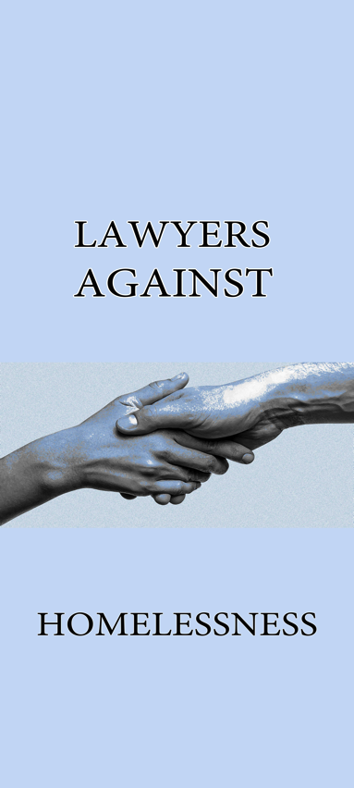
Dear Colleague,

Lawyers Against Homelessness is launching our 11TH Summer CPD conference at the Capuchin Day Centre for Homeless People, Bow Street on Thursday, 13 July at 3:30pm.

SPEAKERS:

ETHICS | PERSONAL INJURY LAW | PROFESSIONAL NEGLIGENCE
- Sara Phelan SC,  Chairman of the Bar Council  - Sinéad Keavey, Solicitor | - Judge Leonie Reynolds  - Declan O’Flaherty, Solicitor  - David Nolan SC | - Judge Gerard Hogan  - Martin Canny, BL  - James McDermott, BL  - Bill Holohan, Solicitor  - David Allen, BL

To date, we have raised over €250,000, every single penny of which has been given to Brother Kevin and his colleagues towards his lifelong fight against homelessness.

We are now hoping that with your assistance, we can pass the €250,000 mark.

As you are reading this, we would ask you to reach out for your chequebook and write a cheque for €500 made payable to Lawyers Against Homelessness or The Capuchin Day Centre.

Alternatively, you can immediately transfer a generous sum for the conference to Lawyers Against Homelessness:

Acc Name: LAWYERS AGAINST HOMELESSNESS
Acc No.: 54820258
IBAN: IE49 bofi 9000 9254 8202 58

100% of the proceeds of the conferences go direct to the Capuchin Day Centre.

This is your great chance to get 4 CPD points and do what you can and do what you can to help the homeless.

Law firms which have been involved include BLM, Gore & Grimes, Byrne Wallace, A&L Goodbody, McCann FitzGerald, Ennis, Kent Carty, Downes, Ivor Fitzpatrick, Hayes McGrath and many others. The Attorney General, Members of the Judiciary, the Bar Council, the Law Library and many members of the Bar are also involved.

The CPD conference fee is €120 (or €60 for practitioners in years one to five): however we have found that many of our colleagues have donated much in excess of this figure.

Brother Kevin has now left the Capuchin Day Centre to retire after his many years supporting the homeless in Dublin.

His team remain utterly committed to helping the increasing issue of homelessness in Dublin: recent statistics indicate that more than one in three people in emergency accommodation is a child.

We have also been told of the hugely increasing burden because of the plight of Ukrainians fleeing their homeland.

This Seminar Is Open To All Members Of The Legal Profession. Please note that there is high interest in this seminar and in order to secure a place, the enclosed booking form must be completed and returned as soon as possible.

The object of the seminar is to bring practitioners up to speed on legal updates and subjects to be discussed will be:-
- Ethics (one hour);
- Personal Injury Law;
- Professional Negligence

FIRM SPONSORSHIP

We ask you, if you can afford it, for sponsorship of €500.00 per firm in order to assist The Capuchin Day Centre continue with their essential work. The benefits of sponsorship include:

- Five places at the seminar for members of the firm
- Name / logo on the seminar materials
- Firm pop-up banner at the seminar (if desired)
- Firm sponsors listed in the Parchment / Law Society magazine with photographs.

Please now complete the enclosed Booking Form and make cheque payable to The Capuchin Day Centre on or before Thursday, 29 June 2023 and send to Kate Reeves, c/o 5 Inns Court, Winetavern Street, Dublin 8.

Each Barrister/Solicitor, when registering for the seminar, will make a cheque payable directly to The Capuchin Day Centre in the sum of €120 per person for those with over 5 years PQE. For those with less than 5 years PQE, the amount is €60 per person.

It is advisable to book however payment can be made on the day in cash or cheque at registration.

Future Collaboration

In addition to sponsorship, please now confirm whether you would be interested in being involved in our upcoming seminars in November 2023 or March 2024.

Please now (1) complete the enclosed Booking Form and (2) make cheque payable to The Capuchin Day Centre on or before Thursday, 29 June 2023 and send to Kate Reeves, c/o 5 Inns Court, Winetavern Street, Dublin 8 OR transfer to the above mentioned account with reference to your firm.

Kindest regards.

Yours faithfully,

Lawyers Against Homelessness

CONFERENCE INFORMATION

Date: 13 July 2023
Time: 3.30pm to 7.30pm
Location: The Capuchin Day Centre, 29 Bow Street, Dublin 7.
Fees: €120.00 per person (+5 years PQE)
€60.00 per person (-5 years PQE)
Registration: 3.30pm
Opening Address: 4.00pm
Conclusion & Closing: Presentations followed by questions and answers
CPD: 4 Hours PRACTICE MANAGEMENT

Please complete the registration form below and send this with your payment to:-
Lawyers Against Homelessness, Kate Reeves, c/o 5 Inns Court, Winetavern Street, Dublin 8.

Surname: __________________________________________________
First Name: __________________________________________________
Address: __________________________________________________
__________________________________________________
Telephone: _________________________________________
E-Mail Address __________________________________________________

Payment by Cheque: Payable to “The Capuchin Day Centre”
Alternatively, you can immediately transfer a generous sum for the conference to Lawyers Against Homelessness:

Acc Name: LAWYERS AGAINST HOMELESSNESS
Acc No.: 54820258
IBAN: IE49 bofi 9000 9254 8202 58

DISCLAIMER
It may be necessary, for reasons beyond the control of the conference organisers, to alter the content and timing of the program or the identity of the speakers.

