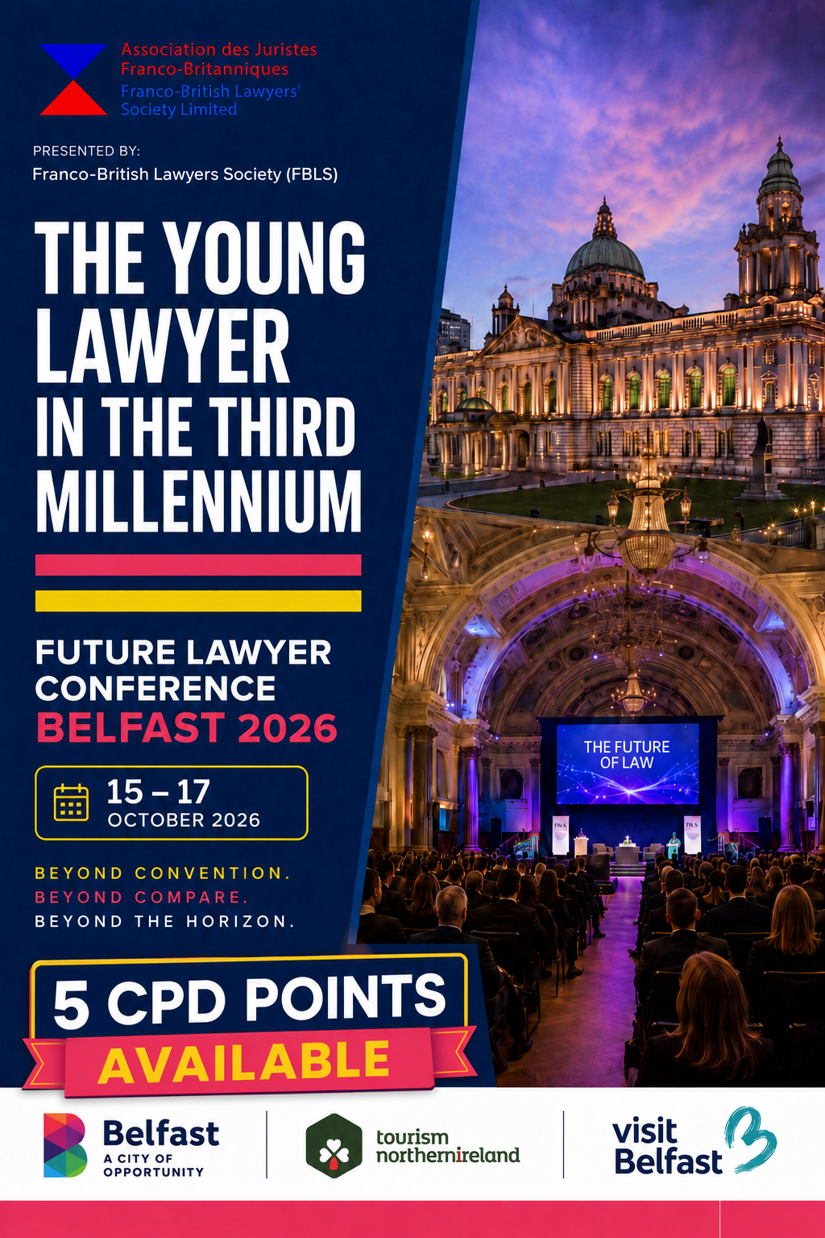

CONTENTS
Future Lawyer Conference 2026 — The Young Lawyer in the Third Millennium

0011 | Foreword — The Rt Hon Lord Justice McCloskey
0022 | Welcome to Belfast
0033 | Why Belfast?
0044 | Programme of Events
0055 | Evening & Weekend Highlights
0066 | Speakers, Moderators & Contributors
0077 | Our Sponsors
0088 | Ulster University Access to Justice LLM
0099 | Venues, Registration & Rates
1110 | Accommodation

welcome all of you with great pleasure to this conference. I extend a particular welcome to those

FOREWORD BY THE RT HON
LORD JUSTICE McCLOSKEY
Franco-British Lawyers Society
I
who have travelled from further afield, particularly from France, England, Wales and Scotland. We, your hosts, receive you warmly.
The Franco-British Lawyers Society, under whose auspices this event is being held, also extends a warm welcome to all non-members. It is our firm hope that you will know a great deal more about the Society by the end of the event.
The FBLS is a registered charity and operates on a non-profit-making basis. Established some 30 years ago, it brings together judges, lawyers, academics, law students and trainees from France and the United Kingdom. Through conferences, seminars, educational activities and professional exchanges, the Society promotes comparative legal discussion, strengthens relationships between the French and British legal communities and advances understanding of French law and the laws of the United Kingdom.
The Society' s annual activities place a strong emphasis on law students and trainees. One of the aims of this October' s event is to give that work a stronger and lasting foundation in Northern Ireland. The Society plans to hold at least one annual careers event for law students and young lawyers in this jurisdiction, while the AI-themed moot will become an annual fixture and will include a prize.
The Society would be delighted to welcome new members, thereby strengthening our Northern Irish connection and section. Membership offers excellent value for money, as well as an opportunity to support the objectives and activities of this registered charity.
Law students, trainee lawyers and young lawyers are front and centre of this event. We look forward particularly to their participation and to welcoming them as new members.
I wish each of you an enjoyable, fulfilling and memorable sojourn in Northern Ireland.
Bernard McCloskey




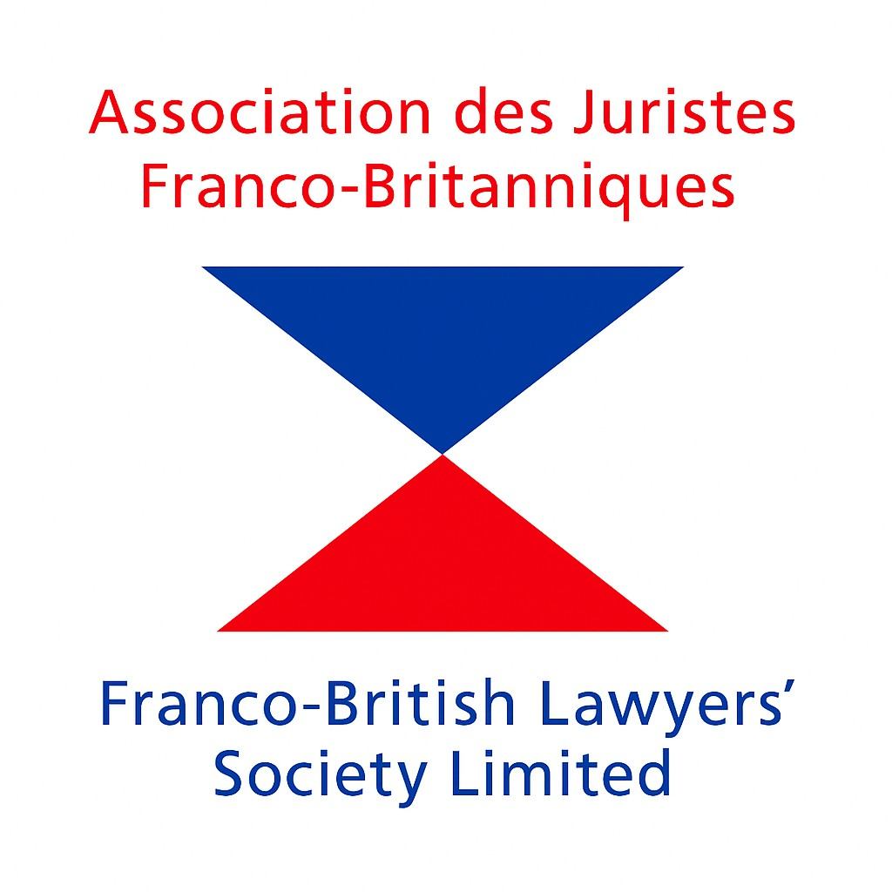
01

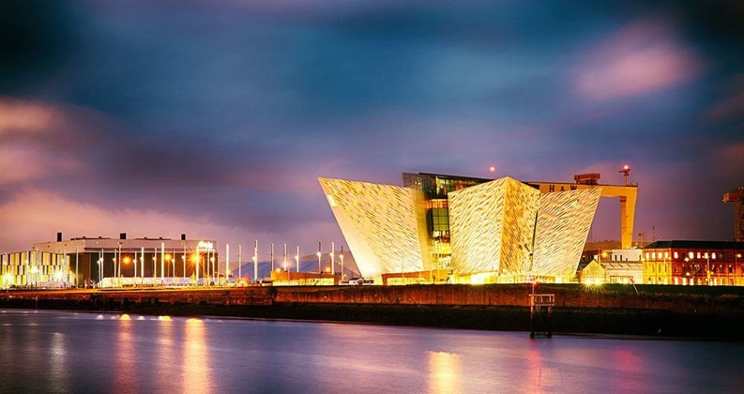

WELCOME TO BELFAST

FUTURE LAWYER CONFERENCE 2026 – THE YOUNG LAWYER IN THE THIRD MILLENNIUM
Belfast provides a distinctive and inspiring setting for this year' s conference. As a city shaped by history, resilience and transformation, it offers a meaningful backdrop for discussion about the future of the legal profession.

Northern Ireland' s legal landscape is internationally recognised for peacebuilding, constitutional law and human rights, and the city today combines global firms, thriving indigenous practices and two world-class law schools at Queen' s University Belfast and Ulster University.
Over the course of the conference, delegates will explore key issues facing the profession today, including artificial intelligence, legal technology, access to justice, cross-border collaboration, professional ethics and the evolving role of young lawyers.
We are delighted to host delegates from across jurisdictions and to showcase Belfast as a vibrant, welcoming and forward-looking legal city. We look forward to welcoming you to what promises to be an engaging, thought-provoking and memorable conference.

A vibrant, welcoming and forward-looking legal city.
02

WHY BELFAST?
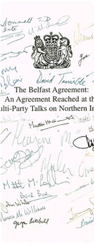
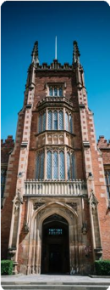

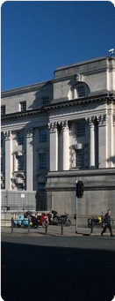
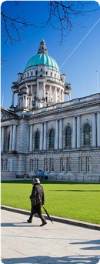

1
A Unique Legal & Constitutional Context
The Good Friday Agreement is internationally recognised as a landmark legal and political achievement, establishing a unique constitutional framework in Northern Ireland — promoting peace, cross-border cooperation and human rights, and influencing comparative constitutional law and transitional justice discussions globally.
2
A Hub for Legal Education & Thought Leadership
Northern Ireland is home to Queen' s University Belfast and Ulster University, both with renowned law schools. Queen' s is a Russell Group institution known for excellence in human rights law, criminology and transitional justice.
3
A Thriving Legal Sector — Global & Home-Grown
Belfast is one of the fastest-growing legal hubs in the UK, having attracted international firms including Allen & Overy, Baker McKenzie and Herbert Smith Freehills Kramer, alongside strong home-grown firms and solicitors.
4
A Welcoming Legal
Community
Northern Ireland offers a strong legal community with support from the Law Society of Northern Ireland, The Bar of Northern Ireland, and influential figures from academia and practice — from senior judges to young solicitors.
5
Vibrant,
Accessible & Safe
Belfast is a vibrant, cosmopolitan, safe and welcoming destination with excellent connectivity to the UK, Europe and beyond, with a strong track record of hosting high-profile legal events including the Commonwealth Lawyers Association Conference 2022.

#FutureLawyerBelfast2026
03

PROGRAMME OF EVENTS

Thursday 15 and Friday 16 October 2026

THURSDAY 15 OCTOBER 2026 — ULSTER UNIVERSITY SCHOOL OF LAW
16:30 | Herbert Smith Freehills AI-Themed Student Moot — leading moot teams from Ulster University (UU) and Queen's University Belfast (QUB)
18:30 approx. | Drinks Reception & Networking — drinks and pizza, sponsored by UU School of Law
20:00 | Dinner — The Academy Restaurant, UU. Approx. £45 per person

FRIDAY 16 OCTOBER 2026 — BELFAST CITY HALL
09:15 | Welcome Address — The Rt Hon Lord Justice McCloskey
SESSION 1 — ARTIFICIAL INTELLIGENCE IN THE LAW · 09:30–12:10
Moderator: Lady Mary Arden
09:30 | “Should Judges Use AI? Lessons from the Hercules Project” — John Keers, Centre for Legal Technology, Ulster University
09:50 | “AI: A Judicial Perspective” — Mr Justice Humphreys, Northern Ireland Court of Judicature
10:10 | “The French Experience” — M. Raphaël Dana, Barreau de Paris
10:30 | “Building AI Guidance for Judges, with Judges” — Dr Tomás McInerney, QUB School of Law
10:50 | Break — Tea & Coffee
Moderator: Frank O'Donoghue KC
11:10 | “Artificial Authority: When AI Invents the Law” — Dr John McCord, Centre for Legal Technology, Ulster University
11:30 | “Ethical Duties in an AI World” — Fiona McLeay, Chief Executive Officer and Commissioner, Legal Services Board, Victoria, Australia
11:50 | Open Forum
SESSION 2 — CYBER CRIME · 12:10–13:10
Moderator: Denise Kiley KC
12:10– | “Challenges and Difficulties in a Digital World” — Charles Gillan, Barrister-at-Law
12:30 | “Cyber Crime in the Age of AI: The Evolving Threat Landscape” — Detective Superintendent Paul Woods, Head of PSNI Cyber, Digital Forensics and Economic Crime
12:50 | “Crime in the Digital Age: What Every Young Barrister Needs to Know” — Bobbie Leigh Herdman, Barrister-at-Law
13:10 | Lunch
SESSION 3 — THE YOUNG LAWYER TODAY AND TOMORROW · 14:00–16:15
Moderator: Shonagh Nelson, Barrister-at-Law
13:55 | “The Future of the Legal Profession” — Lady Leeona Dorrian, Scottish Court of Session
14:15 | “What Does AI Mean for the Lawyers of Today and Tomorrow?” — Jude Copeland, Cleaver Fulton Rankin
14:35 | “Mooting: AI Pitfalls and Benefits” — Cerys Kennedy, Barrister-at-Law, and Sarah Gallan, Barrister-at-Law
14:55 | “From Student to Trainee: Building Meaningful Connections in Law” — Nicola Martin, Trainee Solicitor, Lindsays LLP
15:15 | Comfort Break
15:30 · Moderator: Emma McIlveen, Barrister-at-Law
15:30 | “Same Profession, Different World: A Cross-Generational Conversation” — Inter-Generational Panel: Shea Glasgow, Shannon Gawley, Michelle Cully, Tom Gyle and Olivia Jordan
15:55 | Open Forum & Closing Remarks — Simon Horsington, Vice-President, FBLS
16:15 | Close

04

EVENING & WEEKEND HIGHLIGHTS
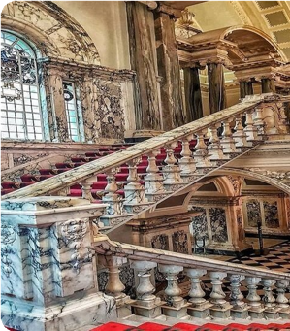
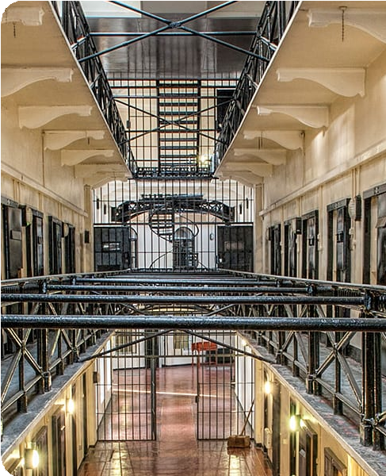

FRI DAY 1 6 OCTOBER · BELFAST CI TY HALL

GALA DINNER
19:15 — Prosecco Reception with live Irish music &
Irish dancing
20:00 — Dinner, three courses
Guest Speaker — Lady Mary Arden

Dress code: Black Tie / Smart Formal

SATURDAY 1 7 OCTOBER · OPTI ONAL CULTURAL ACTI VI TY

CRUMLIN ROAD
GAOL TOUR
Join an escorted tour of Crumlin Road Gaol, one of Belfast's most historic landmarks.

Depart — Belfast City Hall, 09:45am
Return — 1:00pm
Cost — £30 per person, incl. transport and
refreshments

05

SPEAKERS, MODERATORS & CONTRIBUTORS
SPEAKER | CAREER TITLE | ORGANISATION
Lady Mary Arden | Former Justice of the Supreme Court of the United Kingdom | Supreme Court of the United Kingdom
The Rt Hon Lord Justice McCloskey | Lord Justice of Appeal | Judiciary of Northern Ireland
Mr Justice Humphreys | High Court Judge | Judiciary of Northern Ireland
Lady Leeona Dorrian | Former Lord Justice Clerk / Senator of the College of Justice | Court of Session, Scotland
Judge Fionnuala A. Connolly | Judge of the Royal Court of Guernsey | Royal Court of Guernsey
Frank O'Donoghue KC | King's Counsel | The Bar of Northern Ireland
Denise Kiley KC | King's Counsel | The Bar of Northern Ireland
Bobbie Leigh Herdman | Barrister-at-Law | The Bar of Northern Ireland
Emma McIlveen | Barrister-at-Law | The Bar of Northern Ireland
Shea Glasgow | Barrister-at-Law | The Bar of Northern Ireland
Sarah Gallan | Barrister-at-Law | The Bar of Northern Ireland
Shonagh Nelson | Barrister-at-Law | The Bar of Northern Ireland
Cerys Kennedy | Barrister-at-Law | The Bar of Northern Ireland
Charles Gillan | Barrister-at-Law | The Bar of Northern Ireland
Simon Horsington | Barrister / Founder and Honorary Vice-President | Franco-British Lawyers Society
Fiona McLeay | CEO & Commissioner, Victorian Legal Services Board | Victorian Legal Services Board
M. Raphaël Dana | Avocat au Barreau de Paris / Member of the Paris Bar | Barreau de Paris
Det. Supt. Paul Woods | Head of PSNI Cyber, Digital Forensics and Economic Crime | Police Service of Northern Ireland
Michelle Cully | Director, Dispute Resolution UK & ROI | DWF
Jude Copeland | Legal Technology and AI Specialist / Legal Technology Lead | Cleaver Fulton Rankin
Shannon Gawley | Associate, Commercial Team | Carson McDowell
John Keers | Director, Centre for Legal Technology / Lecturer in Law | Ulster University
Dr John McCord | Senior Lecturer, School of Law / Research Lead, Centre for Legal Technology | Ulster University
Dr Tomás McInerney | Lecturer in Law | Queen's University Belfast, School of Law
Nicola Martin | Trainee Solicitor, Scotland | Lindsays LLP
Tom Gyle | Law Student | Ulster University
Olivia Jordan | Law Student | Queen's University Belfast
Falon McLean | Pupil Barrister | The Bar of Northern Ireland

Speaker, moderator and contributor details are subject to final confirmation.
06

OUR SPONSORS & PARTNERS


Herbert Smith Freehills Kramer





A&O Shearman O'Reilly Stewart Solicitors Donnelly and Wall, Solicitors and Notary

Public

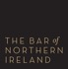

The Bar of NI Law Society of NI DWF




Ulster University Tourism NI Belfast City Council

07

ACCESS TO LAW
Opening the profession to the next generation
A profession is only as strong as the breadth of people it draws upon. The Society supports widening access to law and the legal profession, ensuring that talent, not background, determines who shapes the professionʼs future. This conference has a particular focus on early-career lawyers, law students and those from under-represented communities.
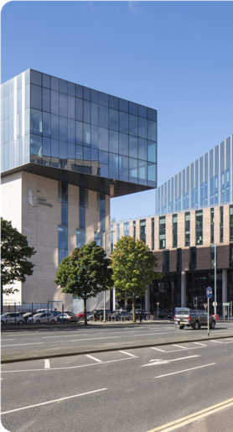

IN PARTNERSHIP WITH ULSTER UNIVERSITY
LLM in Access
to Justice
Ulster University' s LLM in Access to Justice is a unique clinical legal education programme in Northern Ireland, with no directly comparable undergraduate or postgraduate course on the island of Ireland.
Through the Ulster University Law Clinic, students gain practical experience in legal advice, advocacy and client care, including tribunal representation and involvement in family law matters. The programme directly engages with unmet legal need, equality of arms and the practical barriers individuals face in accessing justice.
A distinctive clinical legal education programme placing students at the heart of advice, advocacy and access to justice.
FIND OUT MORE →

ulster.ac.uk/courses/202627/access-to-justice-40504

08

CONFERENCE VENUES
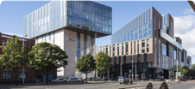

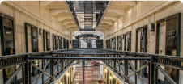

ULSTER UNIVERSITY SCHOOL OF LAW
Day 1 moot & reception. York Street, Belfast BT15 1ED

BELFAST CITY HALL
Day 2 sessions & Gala Dinner. Donegall Square, Belfast BT1 5GS

CRUMLIN ROAD GAOL
Saturday tour. 53–55 Crumlin Road, Belfast BT14 6ST

REGISTRATION & RATES

FBLS Member £95 | FBLS Member | £150 | FBLS Member | £80
Non-Member £110 | Non-Member | £175 | Non-Member | £90
Academics £60 | Students / Pupils / IPLS | £40 | Academics | £60
Students / Pupil Barristers FREE  / IPLS Trainees / | Trainees / Apprentices |  | Law Students / IPLS  Trainees / Apprentices | £40
Apprentices |  |  | Solicitors & Barristers up to | £55
Barristers / Solicitors up to FREE |  |  | 3 years' call
2 years' call
Barristers / Solicitors 3–5 £50
years' call
Speakers CONFERENCE FREE

All conference rates are inclusive of the Reception on 15 October, as well as refreshments and lunch on 16 October.
CONFERENCE ONLY · 15–16 OCT
CONFERENCE & GALA
DINNER
GALA DINNER ONLY
THURSDAY DINNER · 15 OCTOBER — THE ACADEMYRESTAURANT, ULSTER UNIVERSITY
Dinner begins at 20:00. The approximate cost is £45 per person. Delegates should make their own booking directly with the restaurant by telephoning (028) 9536 7332 and asking for Matthew, the Manager.
OPTIONAL CULTURAL ACTIVITY· 17 OCTOBER — CRUMLIN ROAD GAOL ESCORTED TOUR
Depart Belfast City Hall: 09:45am · Return: 1:00pm · £30 per person, to include transport and refreshments.
REGISTER NOW Booking and registration details to follow.

09

ACCOMMODATION IN BELFAST

HOTEL | STARS | ESTIMATED RATE FROM* | BOOKING DETAILS / PROMO CODE
Fitzwilliam Hotel Belfast | ★★★★★ | £215 | Contact Megan Best directly and mention the British Lawyers Society: mbest@fitzwilliamhotelbelfast.com
Grand Central Hotel | ★★★★★ | £200
DoubleTree by Hilton Belfast City Ten Square | ★★★★ | £173 | Group code: TYL3MC  Select 'Special Rates' and enter the code in the 'Group Code' section.
Europa Belfast | ★★★★ | £150
Clayton Hotel | ★★★★ | £145
Maldron Hotel | ★★★★ | £145
Hilton Hotel Belfast | ★★★★ | £179
Holiday Inn Belfast City | ★★★★ | £152
Travelodge | ★★★ | £95

*Delegates are advised to quote “Future Lawyer Conference 2026” when booking directly with participating hotels. The rates below are indicative only and are subject to availability and confirmation by the hotel.

10





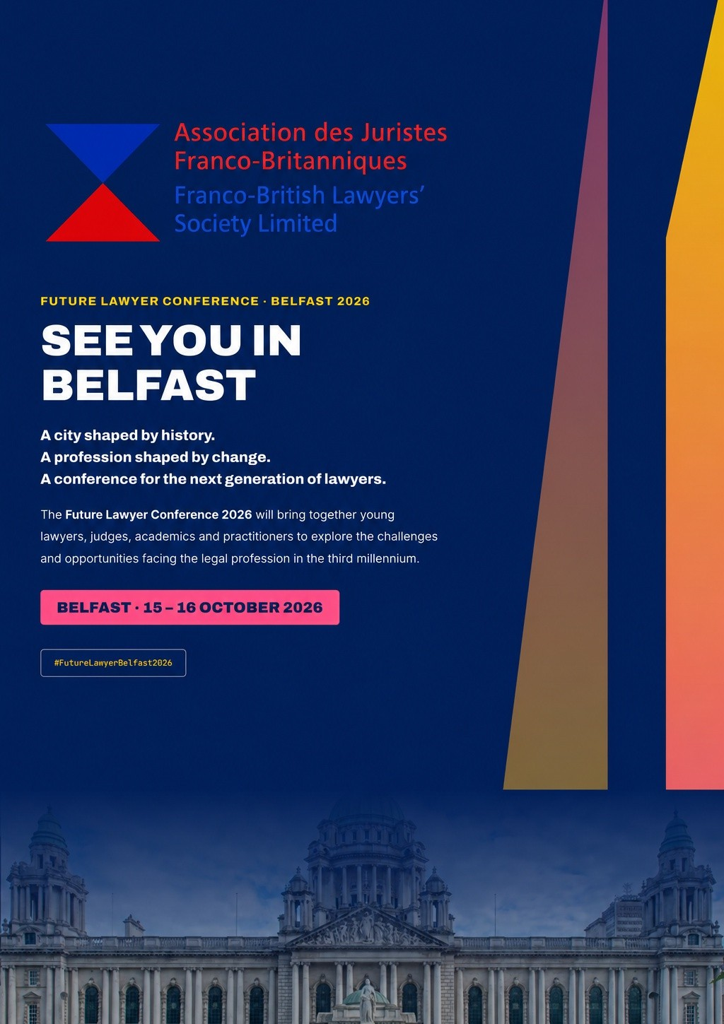

FUTURE LAWYER CONFERENCE · BELFAST 2026

SEE YOU IN
BELFAST
A city shaped by history.
A profession shaped by change.
A conference for the next generation of lawyers.
The Future Lawyer Conference 2026 will bring together young lawyers, judges, academics and practitioners to explore the challenges and opportunities facing the legal profession in the third millennium.

BELFAST · 15 – 16 OCTOBER 2026

#FutureLawyerBelfast2026

